
March monthly report
Project Title:
Conversion of post-combustion gas from cement manufacturing to syngas by electrochemical CO₂ capture and reduction
……..........................................................
Dr. Pongkarn Chakthranont
Sothearoth Heng
NCR ID: 803198
Under the supervision of
Dr. Pongkarn Chakthranont
Contract Number: NCR-NN-2024-22237-EN
March 2025

- Tasks list for March
- Optimization of the 25cm² CO₂ electrolyzer operating condition:
  - Torque force
  - Cathodic/Anodic flow rate
  - Current density
- CO₂ electrolysis under a pure CO₂ at 200mA/cm² in AEM electrozer system
- Experimental Procedure
Membrane electrode assembly set-up
A 25 cm² MEA electrolyzer was used to evaluate the CO2RR performance under modulated operating conditions. The Ni foam (5.4 x 5.4 cm), bipolar membrane (BPM, 6 x 6 cm), and NiSAC (5 x 5 cm) were employed as the anode, membrane, and cathode electrode, respectively. The MEA was assembled and tightened with a torque force of 35 inch-lbs. 200 ml of 1M KOH was recirculated and used throughout the experiment as the anolyte at 25 ml/min. The humidified CO₂ gas stream was introduced into the cathodic inlet with a total CO₂ flow rate of 150 ml/min. Prior the test, the electrochemical impedance spectroscopy (EIS) and Cyclic voltammetry were measured. Meanwhile, the cathodic outlet was directly injected into an online gas-chromatography for gas products analysis.

- Results
Influence of applied current density on CO2RR performance
Studying the impact of the applied current density in CO₂ electrolysis is crucial as it directly influences the product selectivity, energy efficiency, and overall system performance. The figure 1. Illustrates the CO₂ electrolysis under a pure CO₂ at 100 – 175 mA/cm². The overall system enables to sustain a high CO selectivtiy with FE(CO) > 93% at applied current density range of 100 – 175mA/cm² with a rising overpotential as current density increases from 3.65V at 100mA/cm² to 5.91V at 175mA/cm². Furthermore, it is worth noting that once further ramping the current density to 200mA/cm², we observed a significant drop in CO selectivity with an overshoot cell voltage which could be attributed to either cell failure or electrode degradation at such a high current density. Therefore, further improvement on the overall system such as increasing the catalyst mass loading of the cathode and using IrO₂ anode should be considered.
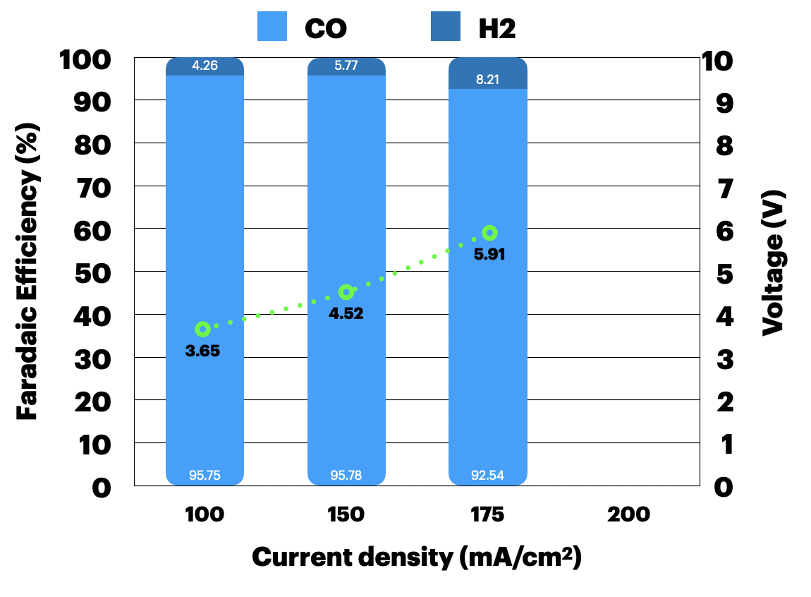
Figure 1. CO₂ electrolysis of a zero-gap MEA (Ni foam/BPM/NiSAC) under a pure 300ml/min CO₂ and 25ml/min of 1M KOH at 100 – 175 mA/cm²

Short-term CO₂ electrolysis of NiSAC under a pure CO₂ condition at 100mA/cm²
To preliminarily determine the stability of the 25cm² electrolyzer with a similar cell configuration and operating condition to 5cm² electrolyzer, the short-term CO₂ electrolysis was experimentally conducted. As can be seen in Fig. 2, the 25cm2 electrolyzer with 1.6mg/cm² NiSAC cathode exhibits a very great performance with FE(CO) > 97% with a slightly high cell voltage of 4.15V over 6hours. According to these results, we hypothetically assume that the NiSAC mass loading could somehow impact the overpotential of the overall cell system but not catalytic performance.
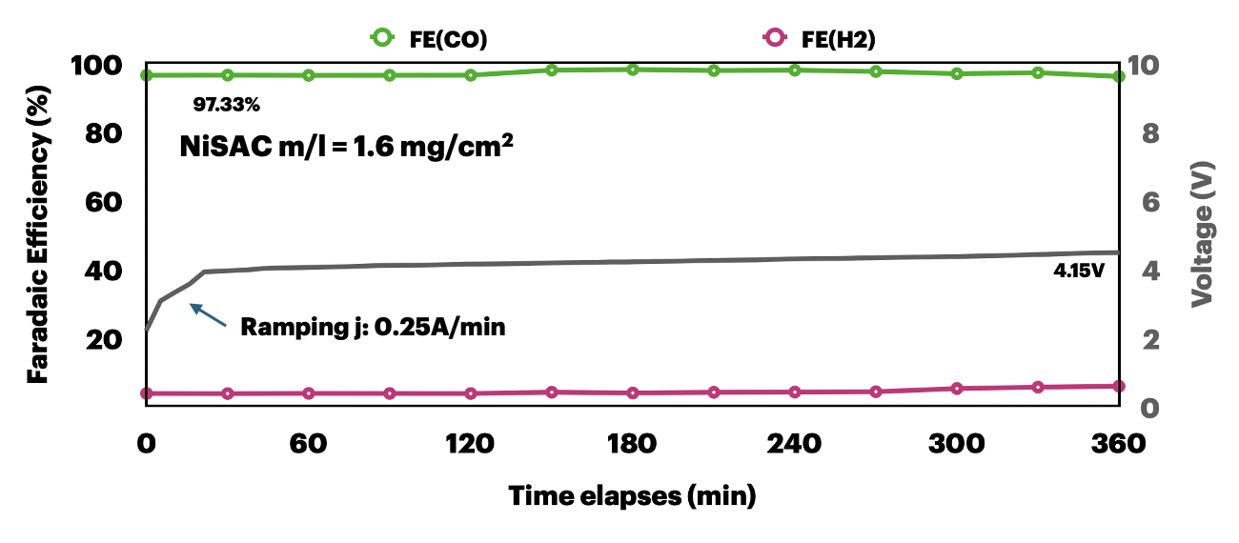
Figure 2. CO₂ electrolysis of a zero-gap MEA (Ni foam/BPM/Ni0.5SAC) under a pure 300ml/min CO₂ and 25ml/min of 1M KOH at 100mA/cm²

CO₂ electrolysis in AEM system under a pure CO₂ condition at 200mA/cm²
In order to evaluate the feasibility of operating a 25 cm² AEM electrolyzer for CO₂ electrolysis at a higher current density with minimal cell voltage, a cell configuration with an anion exchange membrane was deployed and operated under a pure CO₂ flow of 150 mL/min at 200 mA/cm². The overall system was able to sustain CO selectivity similar to that of a BPM electrolyzer, achieving a maximum FE(CO) > 97% with a lower cell voltage of 2.85V. Despite its superior performance in minimizing cell voltage, the AEM electrolyzer demonstrated poor stability due to massive salt buildup during the reaction, leading to cell failure after 40 minutes of operation. However, it is worth noting that the stability of the AEM system can be improved by using a highly diluted electrolyte concentration, a cesium-based electrolyte, and optimized cell temperature, all of which could potentially mitigate cation accumulation at the cathode side over time.
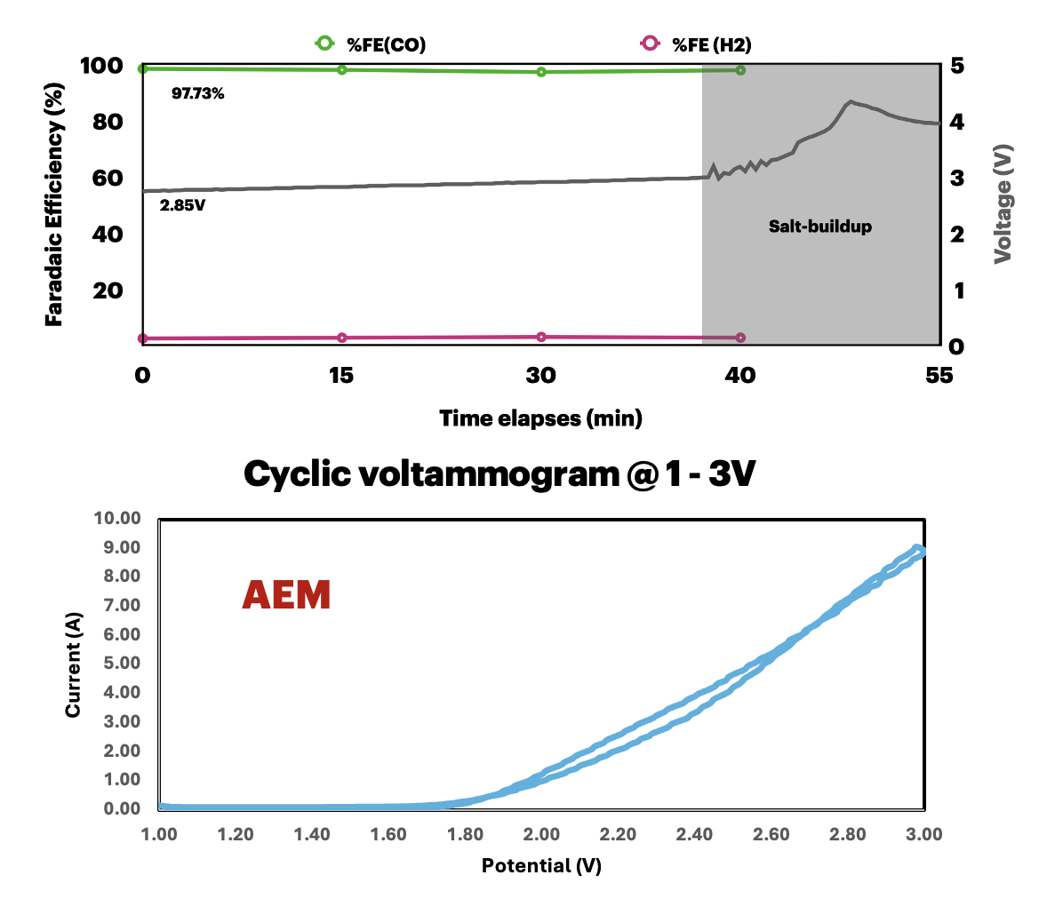

Figure 3. CO₂ electrolysis of a zero-gap MEA (Ni foam/AEM/Ni0.5SAC) under a pure 150ml/min CO₂ and 25ml/min of 1M KOH at 200mA/cm²

- Upcoming tasks
- Influence of catalyst mass loading on the overall cell performance
- Influence of different total CO₂ flow rates on the overall cell performance
- CO₂ electrolysis under a pure CO₂ at 200mA/cm²
- Preparation of IrO₂-TiPt (5.4 x 5.4 cm²) anode

